Like:

1.http://www.iqiyi.com

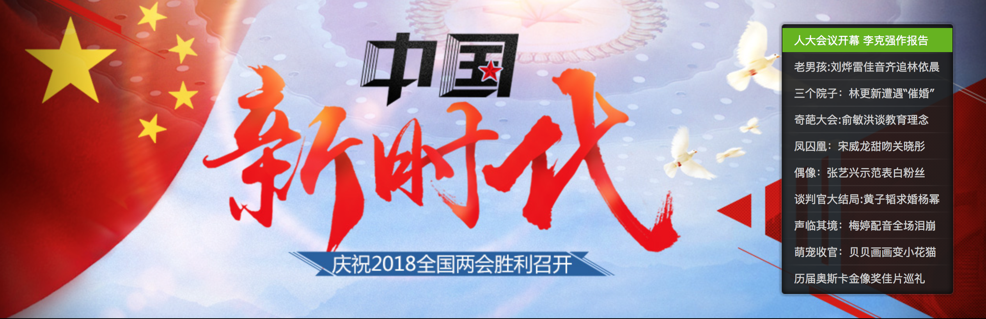

I can see what's hot in this time period.

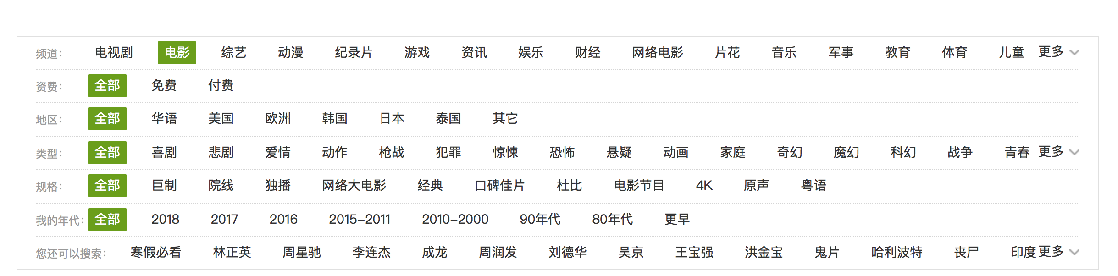

Rich video resources.

2. <https://www.taobao.com>

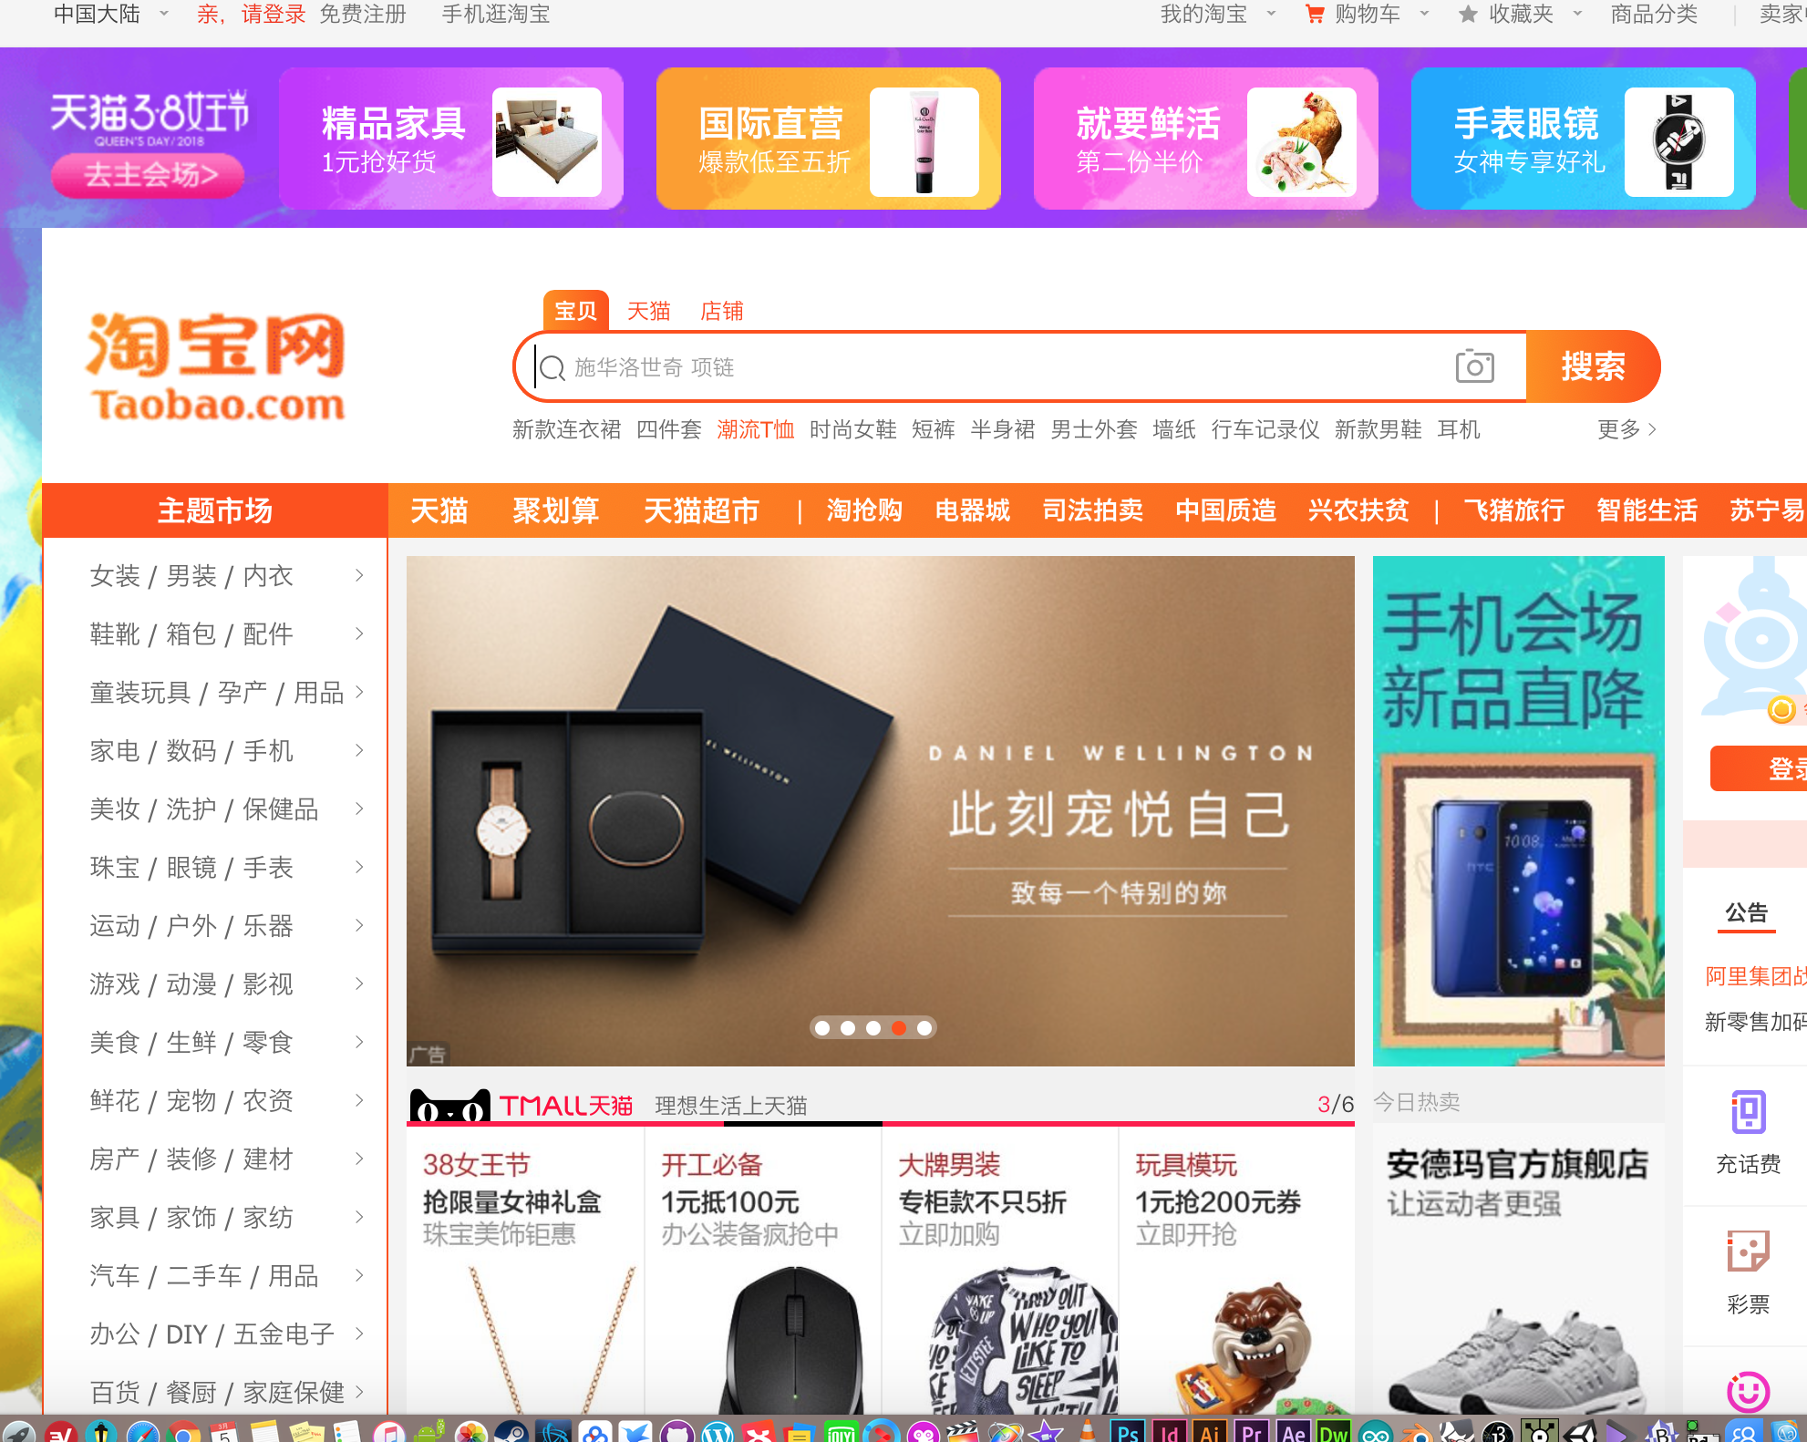

Detailed classification of goods, as well as numerous products.

3. <https://www.pinterest.com>

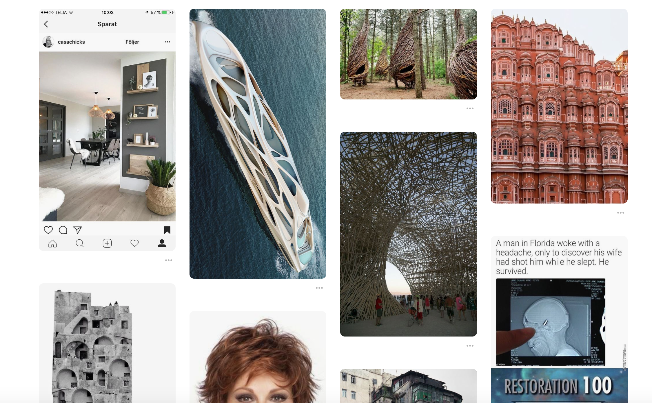

Simple typography and rich artistic resources.

Dislike:

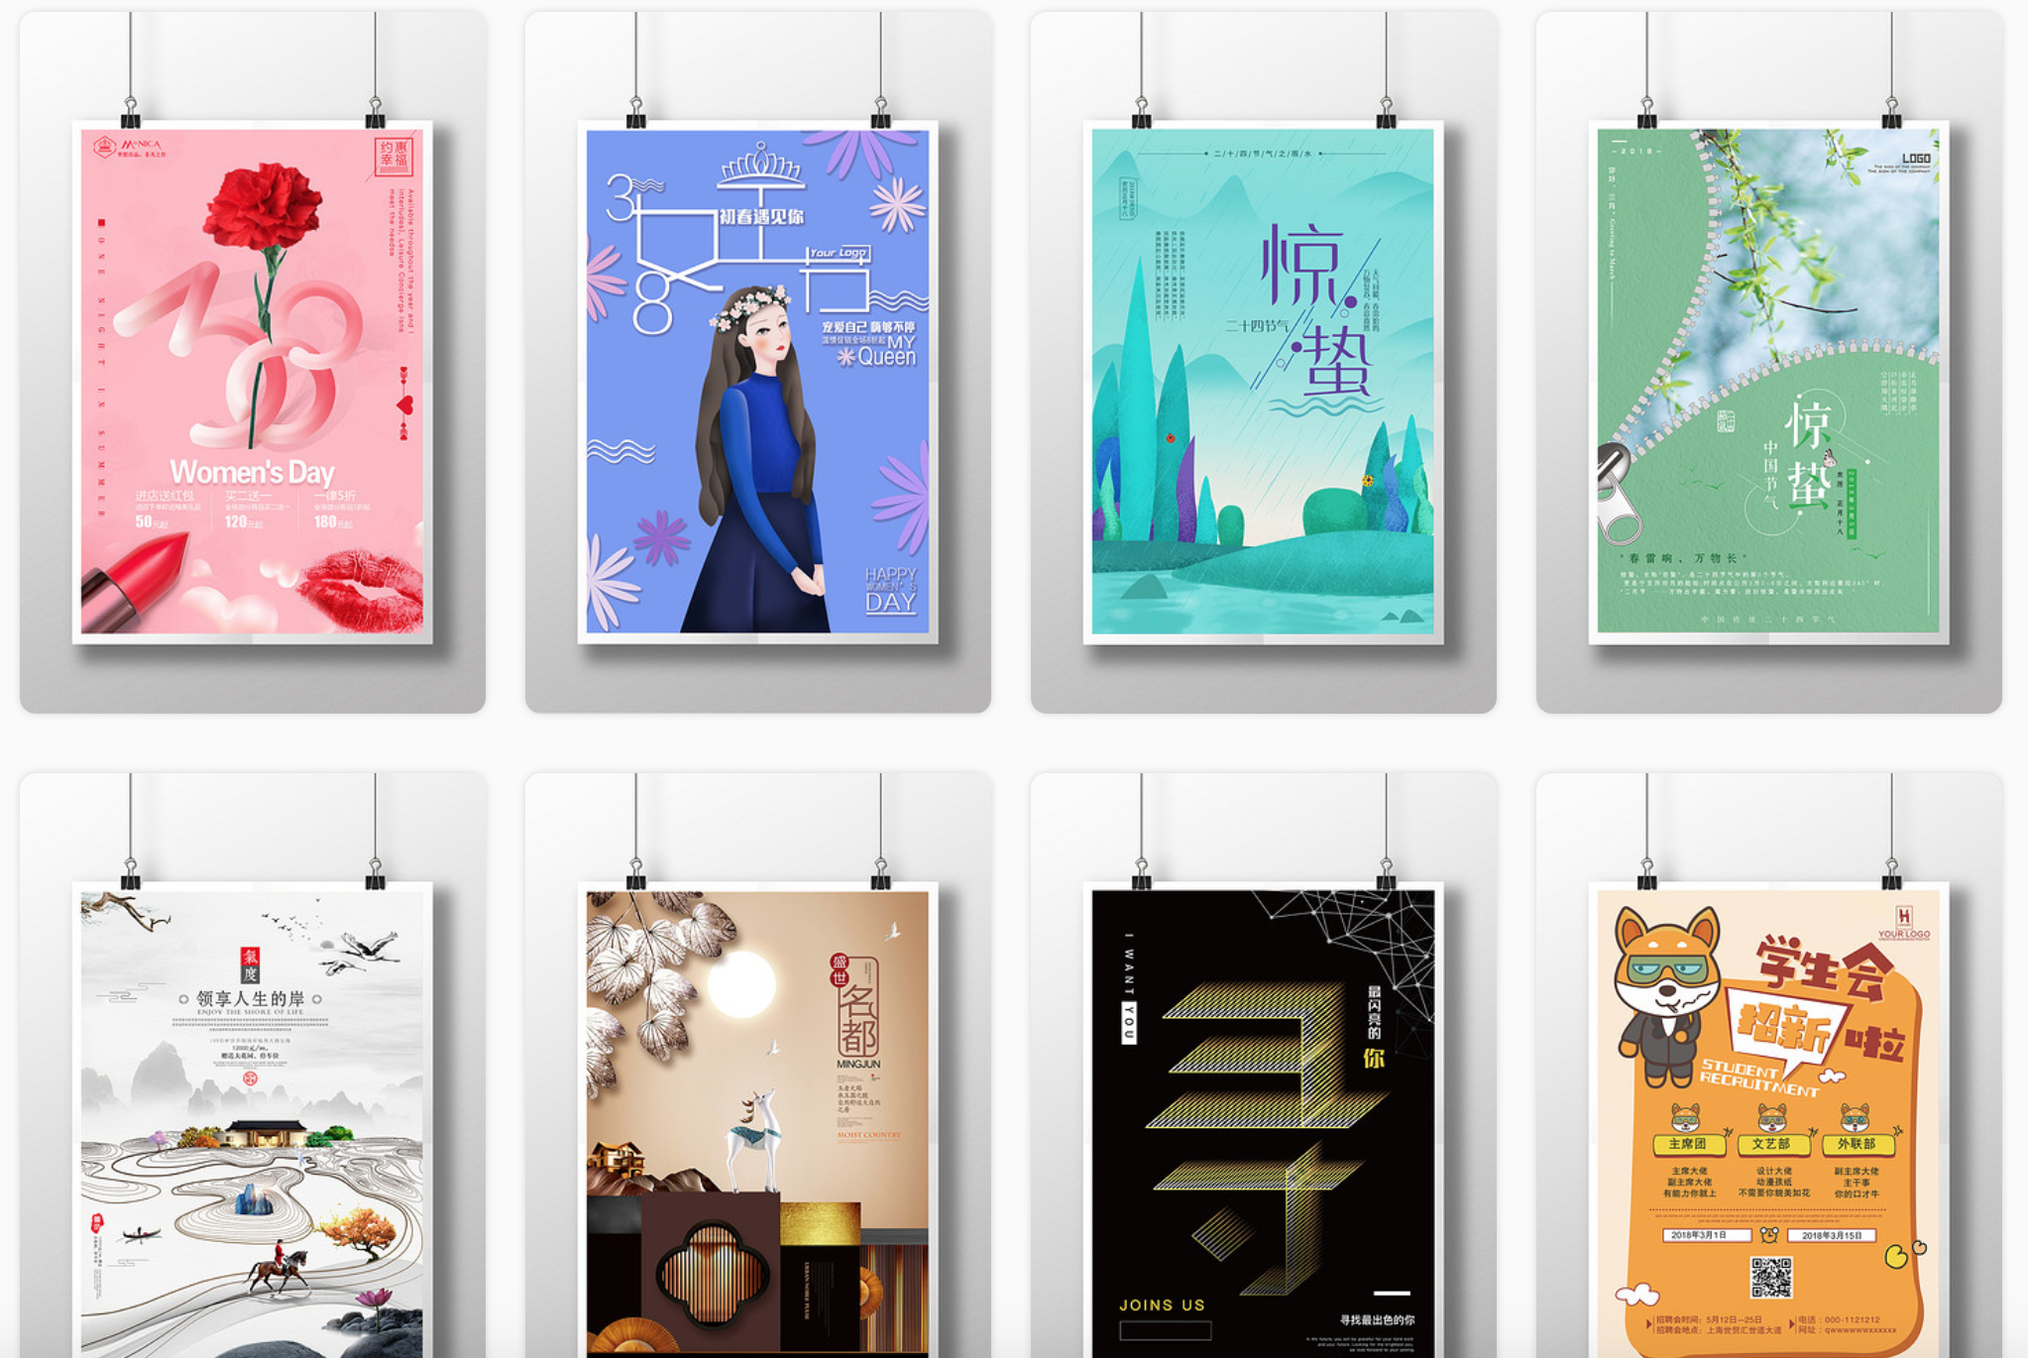1.http://ibaotu.com

Backward design, and not enough resources.

Web design is backward.

2.http://www.cjjjs.com

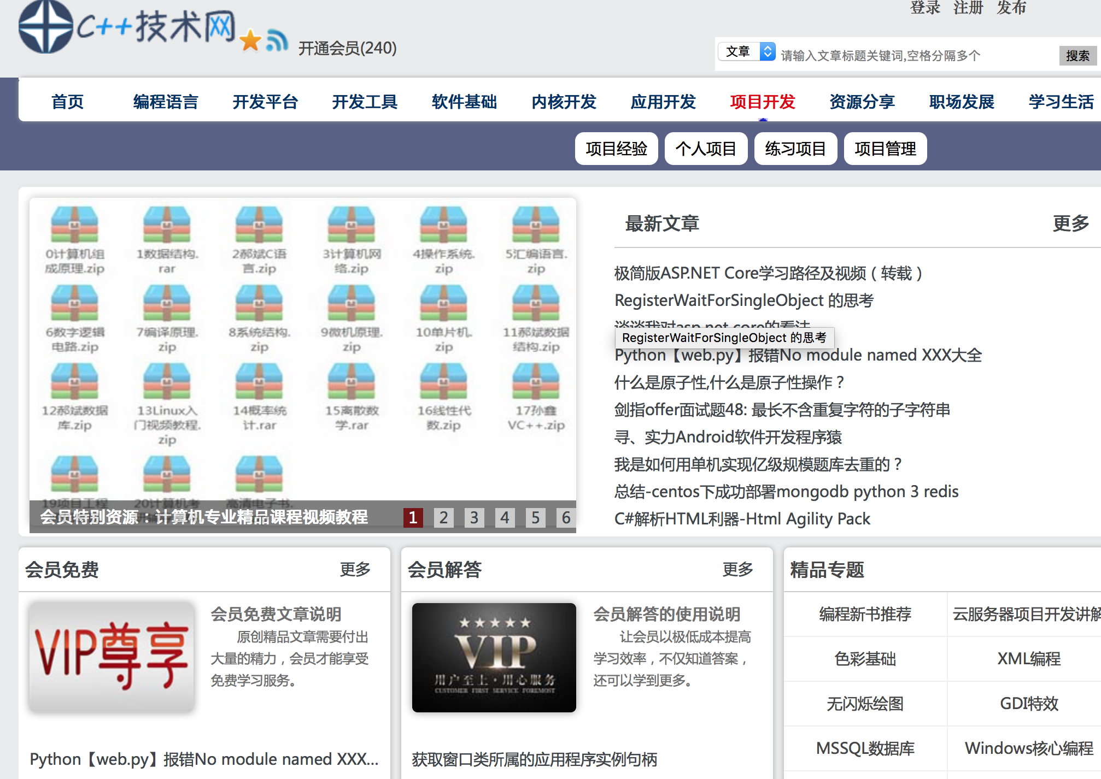

The web design is too conservative, without the main point.